NAME: SAGARSUMAN P MANJHI SUBJECT: PYTHON PROGRAMMING LAB | PRACTICAL: 04 | BATCH : 04  SYBVOC :SEM-III (DS)
Experiment Based on Decision-Making Statements

AIM : To write a Python program to calculate an employee's bonus and final salary based on performance rating using conditional statements (if, if-else, if-elif-else, and nested if).
LEARNING OBJECTIVE :
  - To understand decision-making statements in Python.
  - To learn the use of if, if-else, and if-elif-else statements.
  - To calculate employee bonuses based on performance ratings.
  - To develop logical thinking and problem-solving skills.
TOOLS :

Sr. No. | Name Of Resources | Specification | Quantity | Remarks
1. | Hardware | Computer (i5-i7) Ram (Min 16GB) | 1 | For All Practical
2. | Software | Python / IDLE / VS Code | 1 | For All Practical
THEORY :
1. Decision-Making Statements: Decision-making statements are used to execute different blocks of code based on specified conditions. They help a program make decisions according to the given input.

2. if Statement: The if statement executes a block of code when the specified condition is true.
Example:
if salary > 20000: print("Eligible")

3. if-else Statement: The if-else statement executes one block when the condition is true and another block when it is false.
Example:
if marks >= 40: print("Pass")else: print("Fail")

4. if-elif-else Statement: The if-elif-else statement checks multiple conditions and executes the block corresponding to the first true condition.
Example:
if rate == 5: print("Excellent")elif rate == 4: print("Very Good")else: print("Average")

5. Nested if Statement: A nested if statement is an if statement placed inside another if statement. It is used to check conditions within other conditions.
Example:
if salary > 20000: if rate >= 4: print("Bonus Eligible")
Source Code:
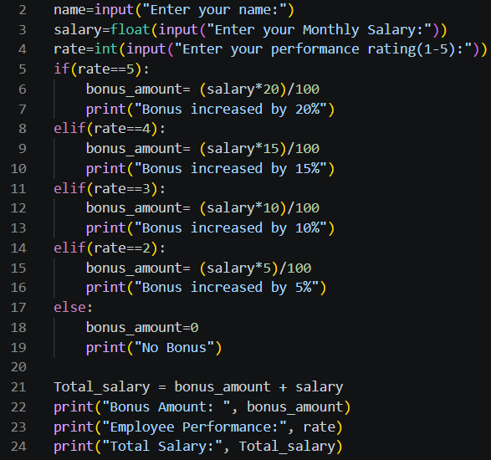
Output:
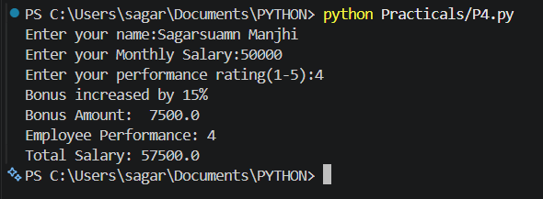
Result and Discussion:
The program successfully calculates an employee's bonus and final salary based on the performance rating. Conditional statements are used to select the appropriate bonus percentage. The bonus amount is added to the monthly salary to determine the final salary.
Learning Outcomes:
- Understood decision-making statements in Python.
- Learned to use if, if-else, and if-elif-else statements.
- Learned to calculate bonuses using percentages.
- Understood how to apply conditions to real-life problems.
Course Outcomes:
- Learned Developed Python programs using conditional statements.
- Applied logical operators and comparison conditions.
- Learned to perform salary and bonus calculations.
- Improved programming and problem-solving skills.
CONCLUSION :
The Employee Bonus Calculation program successfully demonstrates the use of decision-making statements in Python. It calculates the employee's bonus and final salary according to the performance rating and helps understand conditional programming.

VIVA QUESTIONS :

1. What is a decision-making statement?
A decision-making statement executes a block of code based on a condition.

2. What is an if statement?
The if statement executes a block of code when a condition is true.

3. What is the use of an if-else statement?
It executes one block when the condition is true and another block when it is false.

4. What is an if-elif-else statement?
It is used to check multiple conditions and execute the block for the first true condition.

5. What is a nested if statement?
A nested if statement is an if statement inside another if statement.

FOR FACULTY USE ONLY :
Correction Parameters | Formative Assessment [40%] | Timely completion of practical [40%] | Attendance/ Learning Attitude [20%]
Marks Obtained

